Parameter | Description | Estimate | Notes | Source
Alpha | tech parameter | 0.84  0.74 |  | Sharma and Leung 1999  Kompas and Che 2012
Gamma | The elasticity of effort with respect to stock size. | 0.07589 | Gamma = Stock elasticity – 1 / effort elasticity | Pradhan, Sharma, Leung 2003
y | The system equivalence parameter, representing the scaling factor of effort relative to stock. |  | Need to calculate
r | Growth rate | 0.25 | Estimated using the logistic growth MSY formula: MSY=r⋅K4MSY = \frac{r \cdot K}{4}MSY=4r⋅K​, rearranged as r=4⋅MSYKr = \frac{4 \cdot MSY}{K}r=K4⋅MSY​ at biomass B=K2B = \frac{K}{2}B=2K​. For WCPO bigeye, assessed MSY and K values from 2010–2020 suggest r ranges from ~0.19 to ~0.31.
CPUE | Catch per unit effort |  | CPUE = y*s^gamma
CPUE (proxy) | Catch per unit effort | 2.29 | CPUE = pounds sold/trip | NOAA Hawaii Longline Data
Q (proxy) | Catchability coef | 0.001047 | q = catch / (CPUE * Biomass) | NOAA Hawaii Longline data

Year | BET Stock | Maximum  Sustainable Yield | BET Sold  (mt) | Price  (mt) | Cost  per mt
2010 | 623,121 | 76,760 | 4,570.57 | 9,127.15 | 6,062.72
2011 | 623,121 | 76,760 | 4,634.27 | 9,193.28 | 7,583.91
2012 | 623,121 | 76,760 | 4,991.13 | 10,846.75 | 7,892.56
2013 | 742,967 | 108,520 | 5,544.82 | 9,171.24 | 7,032.75
2014 | 742,967 | 108,520 | 5,926.36 | 8,311.43 | 6,547.73
2015 | 742,967 | 108,520 | 7,062.45 | 8,862.59 | 5,092.68
2016 | 742,967 | 108,040 | 6,634.88 | 9,259.42 | 5,202.91
2017 | 665,441 | 159,020 | 6,482.54 | 8,179.16 | 5,401.33
2018 | 655,441 | 159,020 | 6,125.46 | 9,479.89 | 6,591.83

Year | Sector | Species | Sold (mt) | Trips | Biomass (mt) | CPUE | Catchability coef
2010 | Deep | bigeye | 4570.580372 | 1193 | 623,121.00 | 3.83 | 0.001915
2010 | Shallow | bigeye | 48.20150411 | 92 | 623,121.00 | 0.52 | 0.000148
2011 | Deep | bigeye | 4634.275703 | 1250 | 623,121.00 | 3.71 | 0.002006
2011 | Shallow | bigeye | 31.61497219 | 78 | 623,121.00 | 0.41 | 0.000125
2012 | Deep | bigeye | 4991.144279 | 1314 | 623,121.00 | 3.80 | 0.002109
2012 | Shallow | bigeye | 23.7460424 | 67 | 623,121.00 | 0.35 | 0.000108
2013 | Deep | bigeye | 5544.82768 | 1332 | 742,967.00 | 4.16 | 0.001793
2013 | Shallow | bigeye | 14.2078907 | 47 | 742,967.00 | 0.30 | 0.000063
2014 | Deep | bigeye | 5926.37552 | 1305 | 742,967.00 | 4.54 | 0.001756
2014 | Shallow | bigeye | 12.48831998 | 75 | 742,967.00 | 0.17 | 0.000101
2015 | Deep | bigeye | 7062.462012 | 1389 | 742,967.00 | 5.08 | 0.001870
2015 | Shallow | bigeye | 19.4409921 | 62 | 742,967.00 | 0.31 | 0.000083
2016 | Deep | bigeye | 6634.889006 | 1421 | 742,967.00 | 4.67 | 0.001913
2016 | Shallow | bigeye | 8.389654453 | 42 | 742,967.00 | 0.20 | 0.000057
2017 | Deep | bigeye | 6482.550734 | 1478 | 655,441.00 | 4.39 | 0.002255
2017 | Shallow | bigeye | 25.83075541 | 61 | 655,441.00 | 0.42 | 0.000093
2018 | Deep | bigeye | 6125.473642 | 1579 | 655,441.00 | 3.88 | 0.002409
2018 | Shallow | bigeye | 14.48276801 | 27 | 655,441.00 | 0.54 | 0.000041

Estimating Gamma
Ethan: "We have effort as a function of stock, x(s) = y *s^gamma
The stock elasticity of effort is dx/ds * (s/x) which is gamma since:
dx/ds = gamma * y * s^ (gamma-1)dx/ds * s = gamma * y * s^gamma dx/ds * s/x gives the stock elasticity of effort as gamma since x = y *s^gammaNow harvest is given by h = q * s * x^alphaHarvest elasticity of effort is alphaHarvest elasticity of stock is dh/ds * s/h= 1 +[ q*s*alpha * x^(alpha - 1) dx/ds] (s/h)This is 1 + alpha * q * s * x^(alpha - 1) * (dx/ds) * (s/x) * (x/h) which is 1 + alpha * gamma"
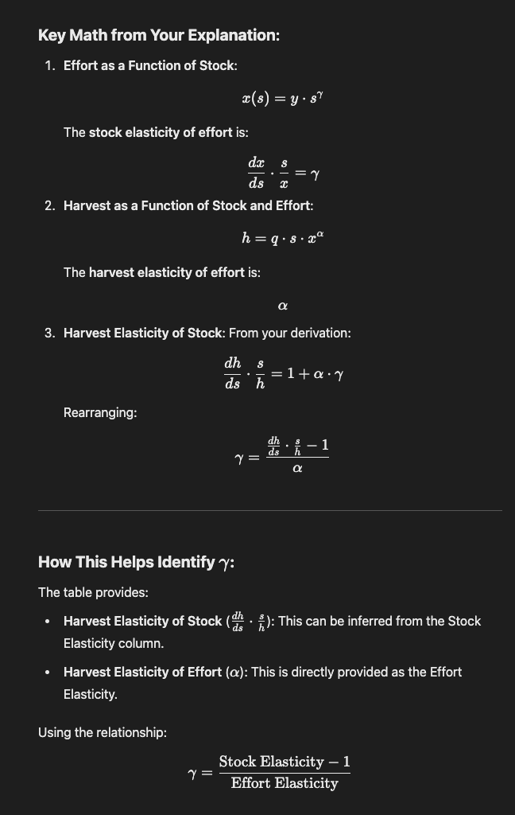

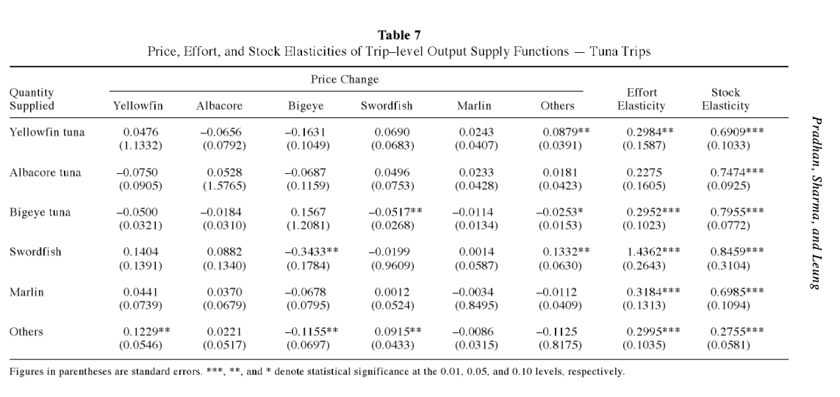
https://www.soest.hawaii.edu/PFRP/reprints/pradhan_analyzing_2003.pdf

Therefore,

Gamma = 0.7955 -1 / 0.2952 = -0.69

CALCULATING y, system eq parameter

We calibrate the parameter
y = 0.157 so that the system equilibrates at the mean level of biomass harvest be10. We adjust Zhang and Smith’s monthly parameter estimates to an annual time scale
where necessary.
Figure 2. Time series of aggregated biomass (squares) and biomass of harvest (circles) of reef fish
Natural Capital: From Metaphor to Measurement Fenichel and Abbott 15tween 1986 and 2004—implying a stock at 24% of carrying capacity

CALCULATE INTRINSIC GROWTH RATE
(I was using von Bertalanffy growth equation which is the growth in length, not population)

$$\dot{s} = rs(1 - \frac{s}{K}) - Q$$
Solve for r,

r =

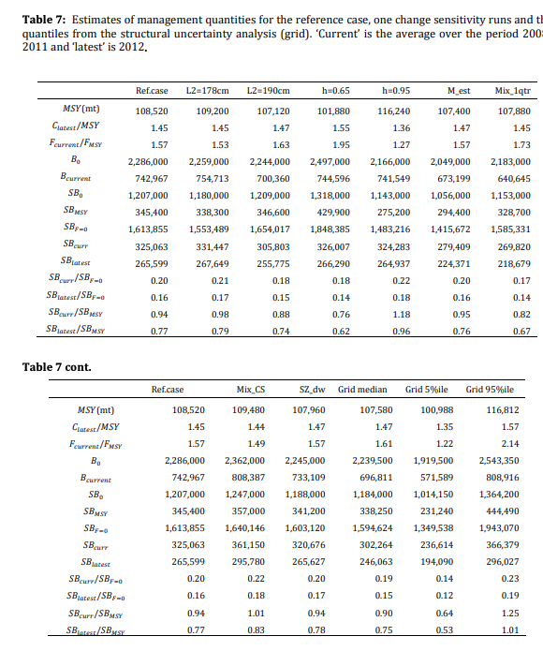

https://palau-data.sprep.org/system/files/Stock%20assessment%20of%20bigeye%20tuna.pdf

